CMP406 Task 2 Log Book

2003115 Robbie Sangster

## Creating Cluster

1. Firstly the vm was opened in VMWare and a skeleton was created to be used as the base for the other nodes called hadoopworker1 through 3 with the original being the hadoopmaster node.

## Confiuration

1. Each node had its hostname changed to distinguish each node.



1. Each nodes hosts file was changed to include all node ip addresses

1. Each nodes netplan installer config file was updated with the nodes ip address.

This was done on each node with the ip address changing for each node.

1. SSH keys were generated in the master node and were saved on each worker node.



## Node Confiuration

The following files were configured for Hadoop.

Hdfs-site.xml

Core-site.xml

Yarn-site.xml

Mapred-site.xml

Workers

The files were then ssh to each worker node as well creating a datanode directory.



The master node was format.



And each datanode.



## Working Nodes

### Pi Example



## SBT Setup

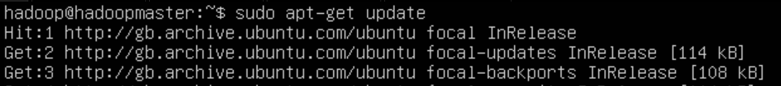







## Spark setup

The following lines were added to the .bashrc file.

And then sourced.



To test spark we will upload the examples files using spark-submit



## Scala Application

The scala application was built in cloudera to test before being moved to the cluster.

Language.sbt file

Language.scala file

## Running Spark

The books, word files and jar file Gutenberg were scp from the host machine to the master.



These were put in the Hadoop dfs directory.



## Running Application



